**Azure fundamentals**

Azure fundamentals is a series of six learning paths:

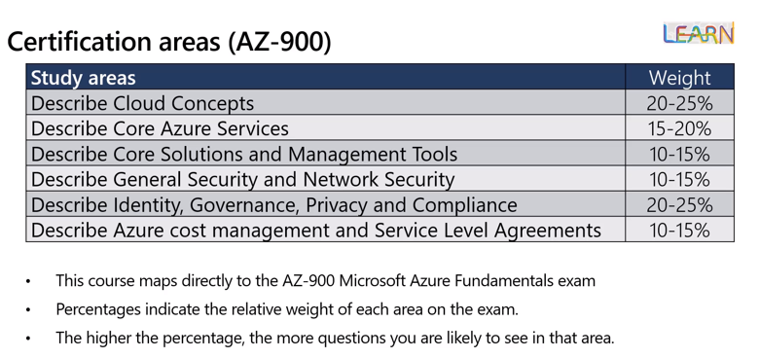

# **What is cloud computing**

It's the delivery of computing services over the internet, which is otherwise known as the cloud. These services include servers, storage, databases, networking, software, analytics, and intelligence. Cloud computing offers faster innovation, flexible resources, and economies of scale.

## What is Azure

Azure is a continually expanding set of cloud services that help your organization meet your current and future business challenges. Azure gives you the freedom to build, manage, and deploy applications on a massive global network using your favorite tools and frameworks.